March 3, 2014

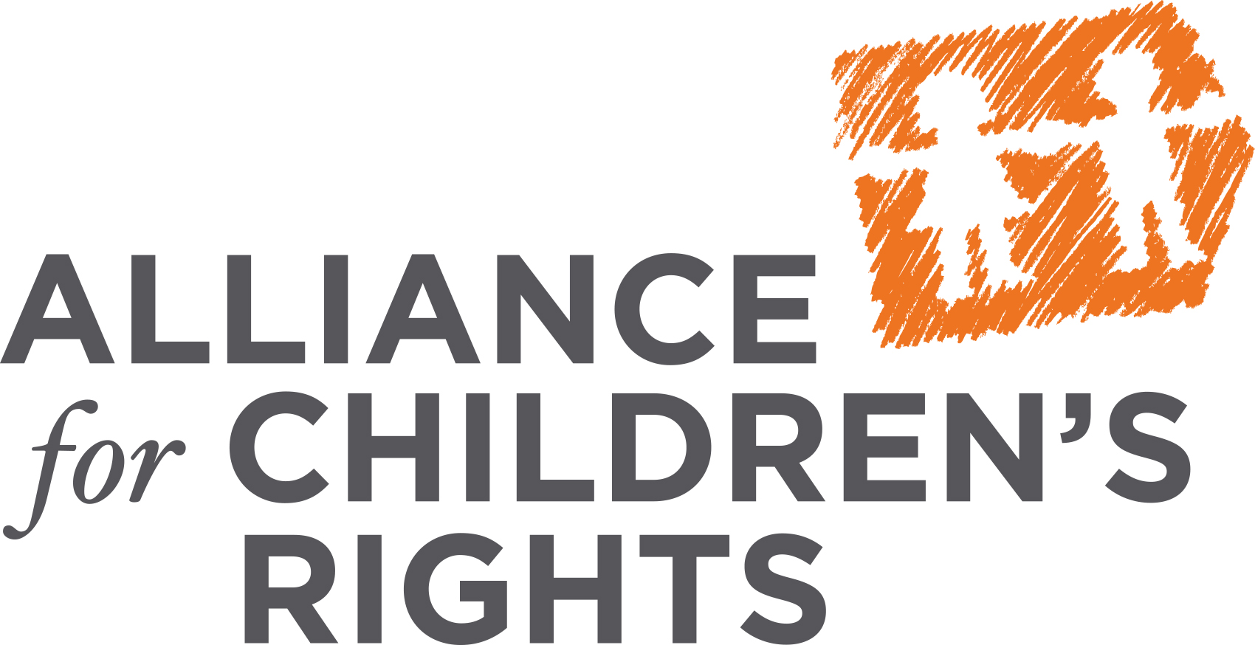

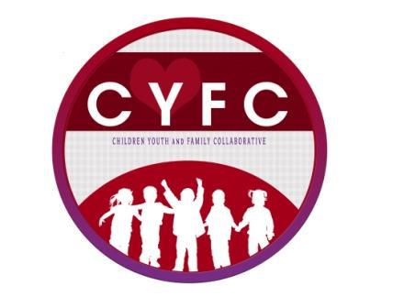
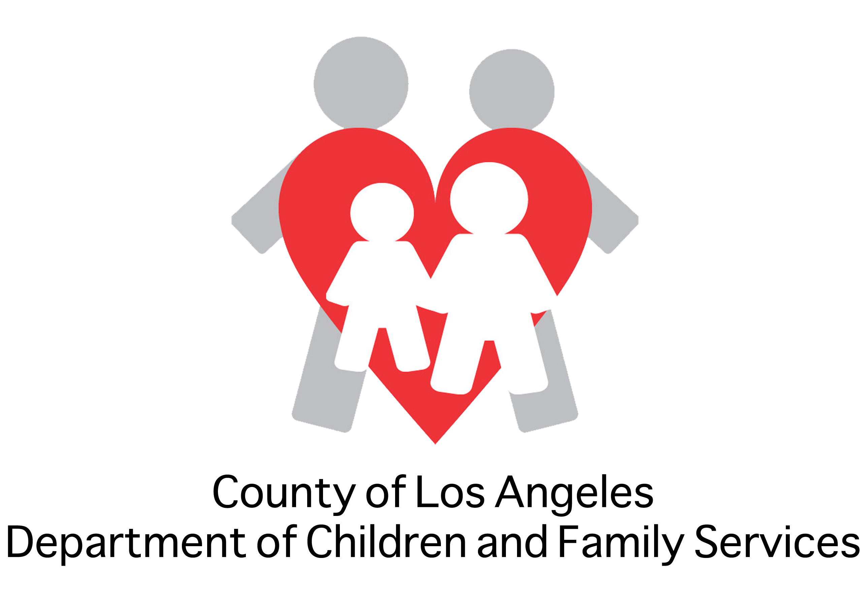


[Name of Recipient]
[Title]
[Affiliation]
[Street Address]
[City, State, Zip Code]

Re: Sample LCAP for Foster Youth

Dear [Name of Recipient]:

We write to share with you an important tool to assist your LEA in developing a Local Control and Accountability Plan (LCAP) that meets the unique needs of foster youth. The attached Sample LCAP for Foster Youth was developed by The Coalition for Educational Equity for Foster Youth, a stakeholder coalition including former foster youth, county child welfare representatives, juvenile court representatives, and foster youth education experts. It has been endorsed by The California Foster Youth Education Task Force, a statewide coalition of over 35 state and local agencies committed to improving the educational outcomes of foster youth.

As you know, in 2013 the landmark Local Control Funding Formula (LCFF) created a more equitable school funding model by recognizing that some students—our low-income, English language learners and foster youth—need additional resources to reach their college and career dreams. 2014 will be a watershed year as school districts create LCAPs to ensure the promise of the LCFF becomes a reality for all students, including our foster youth.

The educational outcomes for foster youth are heartbreakingly poor and significantly worse than other at-risk student subgroups. Foster youth are twice as likely to drop out of school as their peers. Twice as many foster children repeat a grade. Seventy-five percent of foster children are behind grade level. Sixty-seven percent of foster children are suspended from school and 17 percent are expelled, more than three times the general student population. Closing this achievement gap requires programs and services that meet the unique educational needs of foster youth. Absent such targeted interventions foster youth will continue to suffer educational outcomes worse than their low-income peers.

Attached please find a sample LCAP with goals and actions tailored to meet the unique education needs of foster youth. We hope that your LEA will use it to ensure that LCFF fulfills its promise to our foster youth. Please feel free to contact me at [phone/email] should you have any questions.

Thank you,

[Name of Sender]
[Sender’s Organization]

